**COURSE ONE – Exercise 1.**

Here is the data on the costs and benefits of the competing options faced by Sam, the company and the government.

Study this information then answer the questions below.

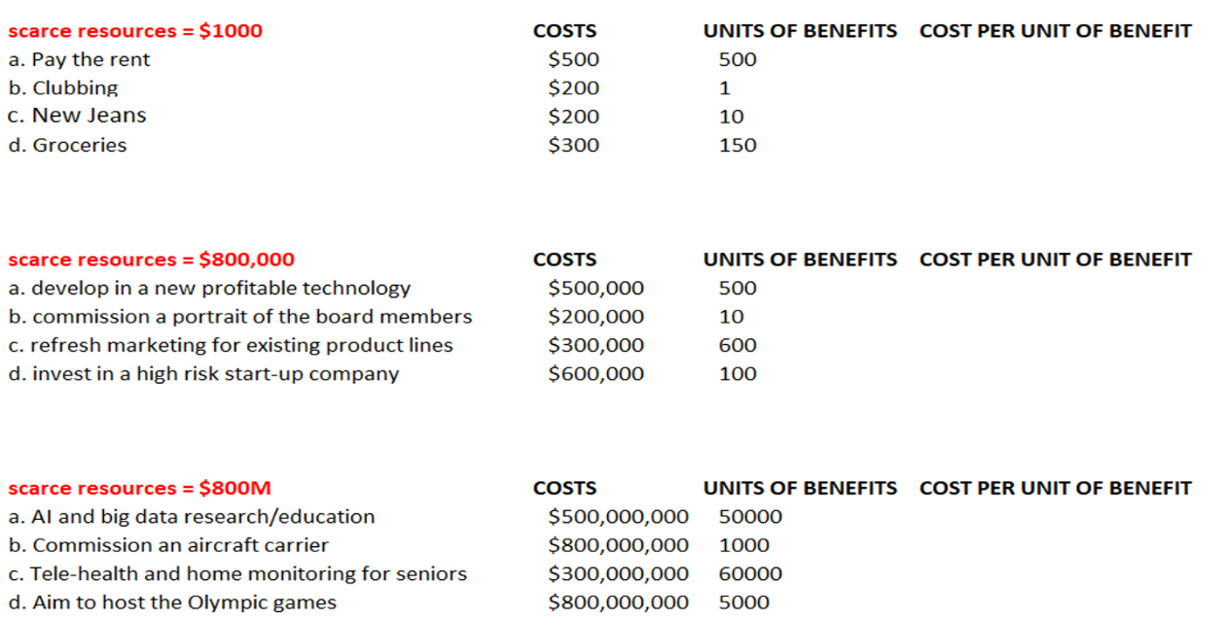

1. Work out the cost per unit of benefit for each option for Sam, the company and the government. Hint, the first answer for Sam is $500/500 = $1
2. For Sam’s choices
   1. work out the total benefits for ‘a+d+c’ and for ‘a+d+b’
   2. why is ‘a+b+c+d’ not possible?
3. For CURE ALL’s choices
   1. What is the best allocation of scarce resources?
   2. Use the data to prove this is the best outcome?
   3. How much worse off would CURE ALL be if they chose ‘b+d’
4. What is the best allocation of scarce resources for the country?