**COURSE ONE – Exercise 2.**

Consider the product ‘bread’.

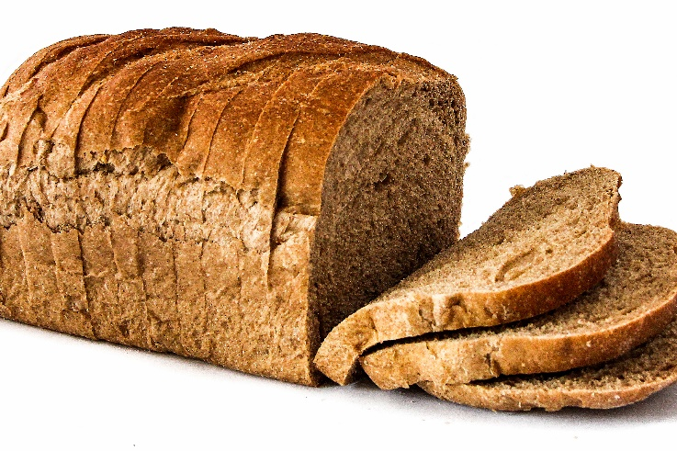

Would a market solve the ‘Black box’ questions of ‘What to produce’, ‘How to produce it’ and ‘For whom?’

This depends on whether the criteria for a ‘well-functioning market’ are met.

Think about the criteria for as they might apply to Bread

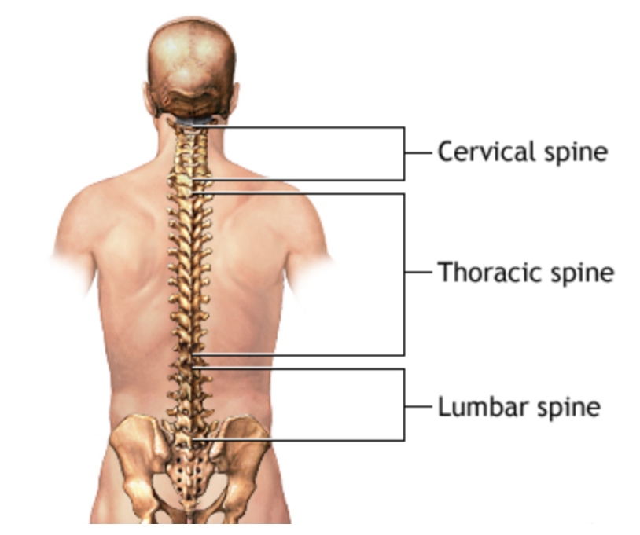

Strong Competition

1. Product is identical/similar
2. Low costs of entry for producers
3. Lots of producers competing hard

Perfect Information

1. Consumers preferences/needs
2. The value of the product
3. Price being charged

Now think about ‘spinal surgery’

How likely are the criteria to be met?