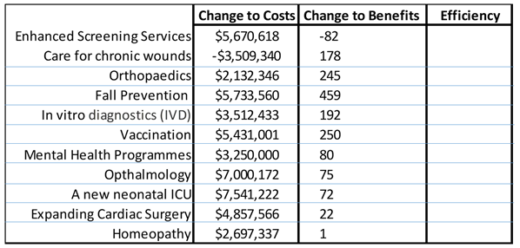**COURSE ONE – Exercise 3.**

1. Write down why we would never choose ‘Enhanced Screening’
2. Write down why we would always choose ‘Care for Chronic wounds’
3. Calculate the efficiency of the remaining options
4. When is the budget of $25M exhausted?
5. When would we stop spending, if our threshold for cost effectiveness was $48,000/QALY
6. Roughly draw the threshold on the graph to confirm this

