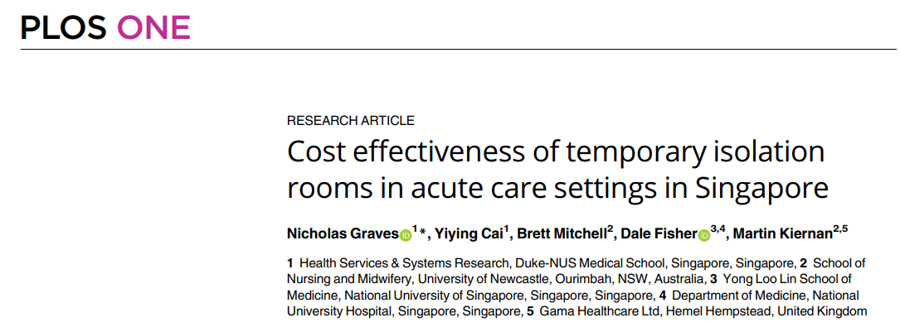**COURSE ONE – Exercise 3.**

1. What are the objectives of this paper?
2. What were the main outcome measures
3. What outcomes were used to address the question of cost-effectiveness?
4. What was the conclusion about cost effectiveness when
   1. Effectiveness was assumed to be 30%
   2. Effectiveness was assumed to be 1%
5. Where did the data come from for this analysis?