**COURSE TWO – Exercise 1.**

Here is the data on the costs and benefits of a telemedicine model to manage patients with chronic diseases at home, thus reducing hospital admissions.



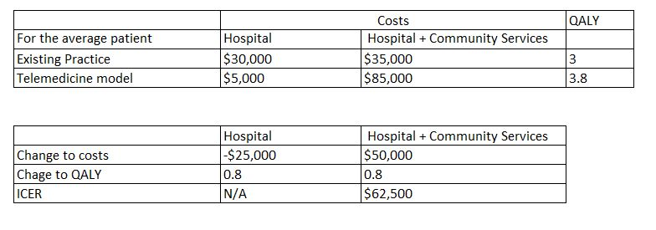

1. Work out the change to costs from adopting this, from the perspective of the ‘Hospital’ and then from the perspective of the ‘Hospital + Community services’
2. Work out the change to QALYs
3. What are the findings
   1. When the perspective of the hospital is taken?
   2. When the perspective of the ‘Hospital + Community services’ is taken?
4. Would you support adoption if you were:
   1. Manager of the hospital?
   2. Manager of the hospital and community services?
   3. Minister for health?