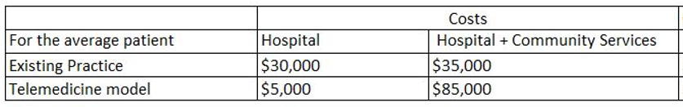**COURSE TWO – Exercise 2.**

We will estimate the annual costs of the new telemedicine service for the Hospital and then for Community services.

1. Use the information below to derive the costs in the table that are highlighted yellow.

* An existing administrator at the hospital is asked to coordinate the service. The full costs of employment for this person are $50,000 and 10% of their time is needed.
* A new administrator is hired by community services at 40% of a full time equivalent to run the service. The full costs of employment for this person are $60,000
* Telemedicine equipment is leased with an annual cost of $15,000 (this includes paying back the loan, 5% interest and service charges)
* Clinical staff are paid $150 per session and there are 100 sessions offered over the course of a year
* A dedicated room is used, with current market rents indicates annual costs of $25,000
* Courier services are needed 170 times, each one costs $35.3

1. Which of these resources/costs are
   1. Humans?
   2. Space?
   3. Things?