**COURSE TWO – Exercise 3.**

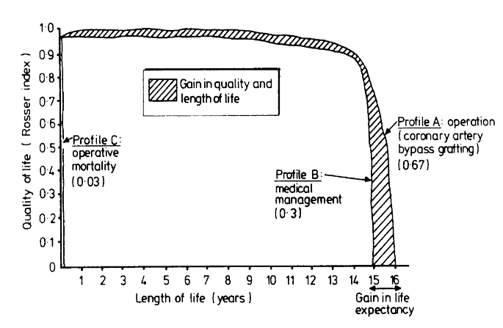

This exercise is about estimating QALYS for two competing options: ‘Existing practice’ vs. ‘New model of care’

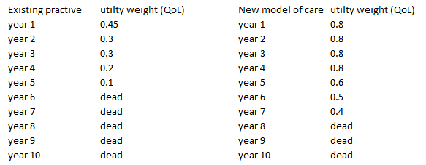

1. How many QALYs are associated with:
   1. Existing practice
   2. New model of care
2. What is the change to QALYS from a decision to adopt ‘New model of care’?
3. How many calendar years are gained?
4. How many QALYS are associated with the extra calendar years gained?