**COURSE THREE – Exercise 1.**

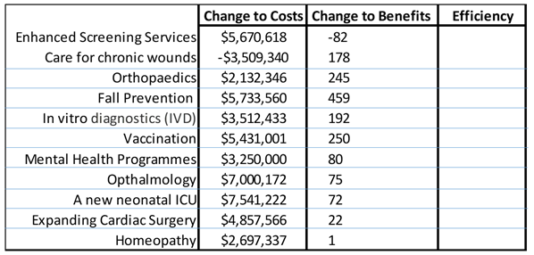

**ICER**

You have seen these data before (COURSE ONE – Exercise 3)

1. Calculate the incremental cost effectiveness ratio (ICER) for each relevant option
2. Which programmes are cost-effective when the threshold is:
   1. $10,000
   2. $20,000
   3. $30,000
   4. $40,000
   5. $50,000
3. Draw the $20,000 threshold as a straight line on the graph