|  |  |  |
| --- | --- | --- |
|  | Costs | Life Years |
| New surgical technique |  |  |
| Old surgical technique |  |  |
| Incremental difference |  |  |

**COURSE FOUR – Exercise 1.**

Evaluate this decision tree and put the results in the table.

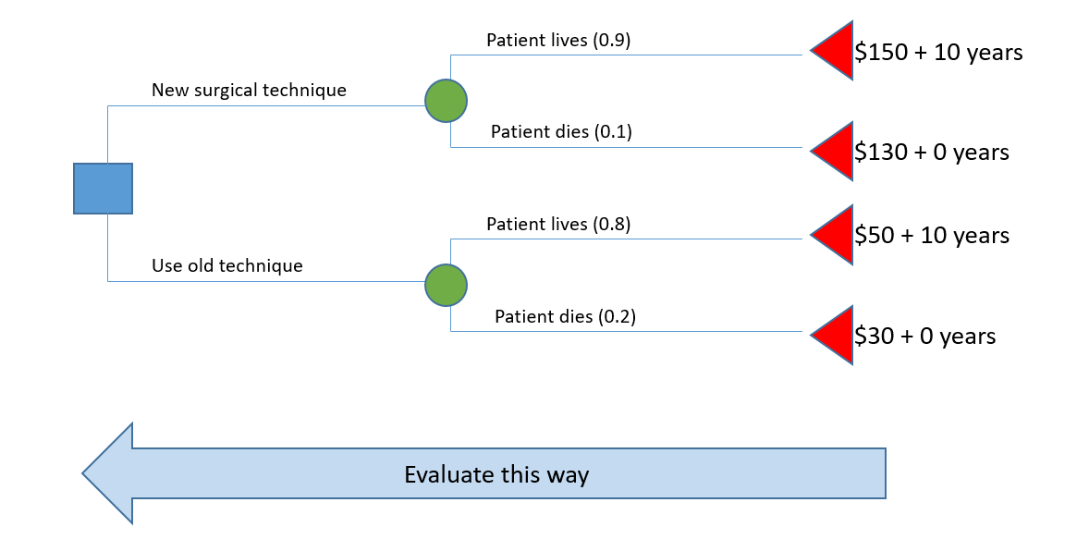

What is the incremental cost-effectiveness ratio for a decision to adopt New vs Old?