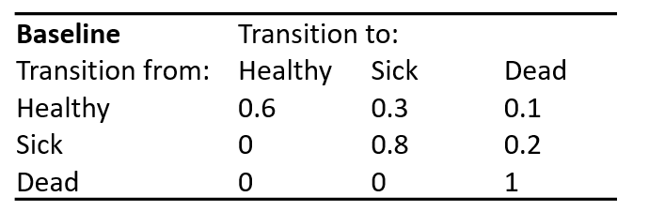**COURSE FOUR – Exercise 2.**

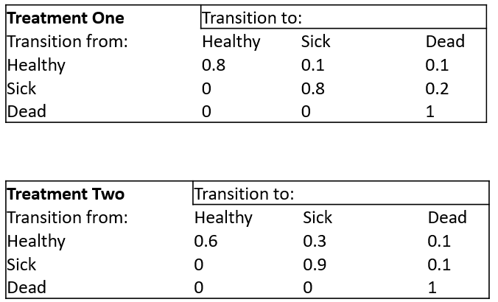Use the data in the three tables to model member ship of the three health states over 10 cycles, you will generate outcomes for Baseline, Treatment One and Treatment two. Using a spreadsheet will make this much easier.

Add in the tariffs for costs and QALYs, taken from the 4th table

Work out the total costs and QALYS for Baseline, Treatment One and Treatment

Calculate the Net Monetary Benefits for all options using a threshold of $20,000

****Which option is best against the criterion of cost-effectiveness?