Duke-NUS Graduate Certificate in Pharmaceutical Regulation Programme
Form A: Please send a copy of this completed form (2 pages) to CoRE_Education@duke-nus.edu.sg

Name of applicant
Number of years of regulatory experience
I am interested in taking | Choose an item.

If you are planning on completing the Graduate Certificate in Pharmaceutical Regulation programme, please indicate the 4 modules that you plan to read:
☐ GMS5011: Fundamentals of Pharmaceutical Regulation
Pre-market Processes
☐ GMS5012: Chemistry, Manufacturing and Controls
☐ GMS5101: Clinical Trial Design and Data Analysis
Post-market Processes
☐ GMS5111: Pharmacovigilance & Risk Management
☐ GMS5113: Post-market Surveillance and Enforcement
Regulatory Trends
☐ GMS5104: Biotherapeutics and Biosimilars
☐ GMS5103: Regulation of Cell, Tissue and Gene Therapies
☐ GMS5105: Generic Medicines

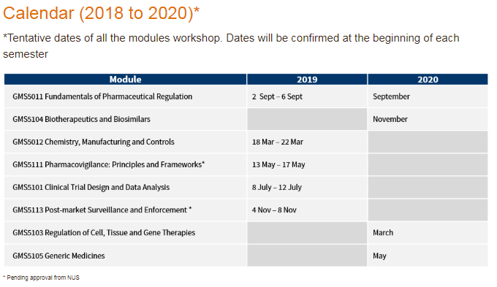

Please indicate your statement of purpose and reason for wanting to read modules from the Graduate Certificate in Pharmaceutical Regulation programme (250 words)
Choose an item.

